AI ASSITED CODING
LAB EXAM-4
NAME:P.NISHANTH
HTNO:2403A52065
BATCH:03 TASK:
Q1 (API Integration)
- Connect to a University Results API
- Add error handling for invalid registration number
PROMPT:
"Write a Python program that connects to a University Results API using the requests module. The program should ask the user to enter a registration number, send it to the API, and print the result. Add error handling for invalid or empty registration number, 404 errors, JSON errors, and connection errors. Keep the code simple with comments." CODE:

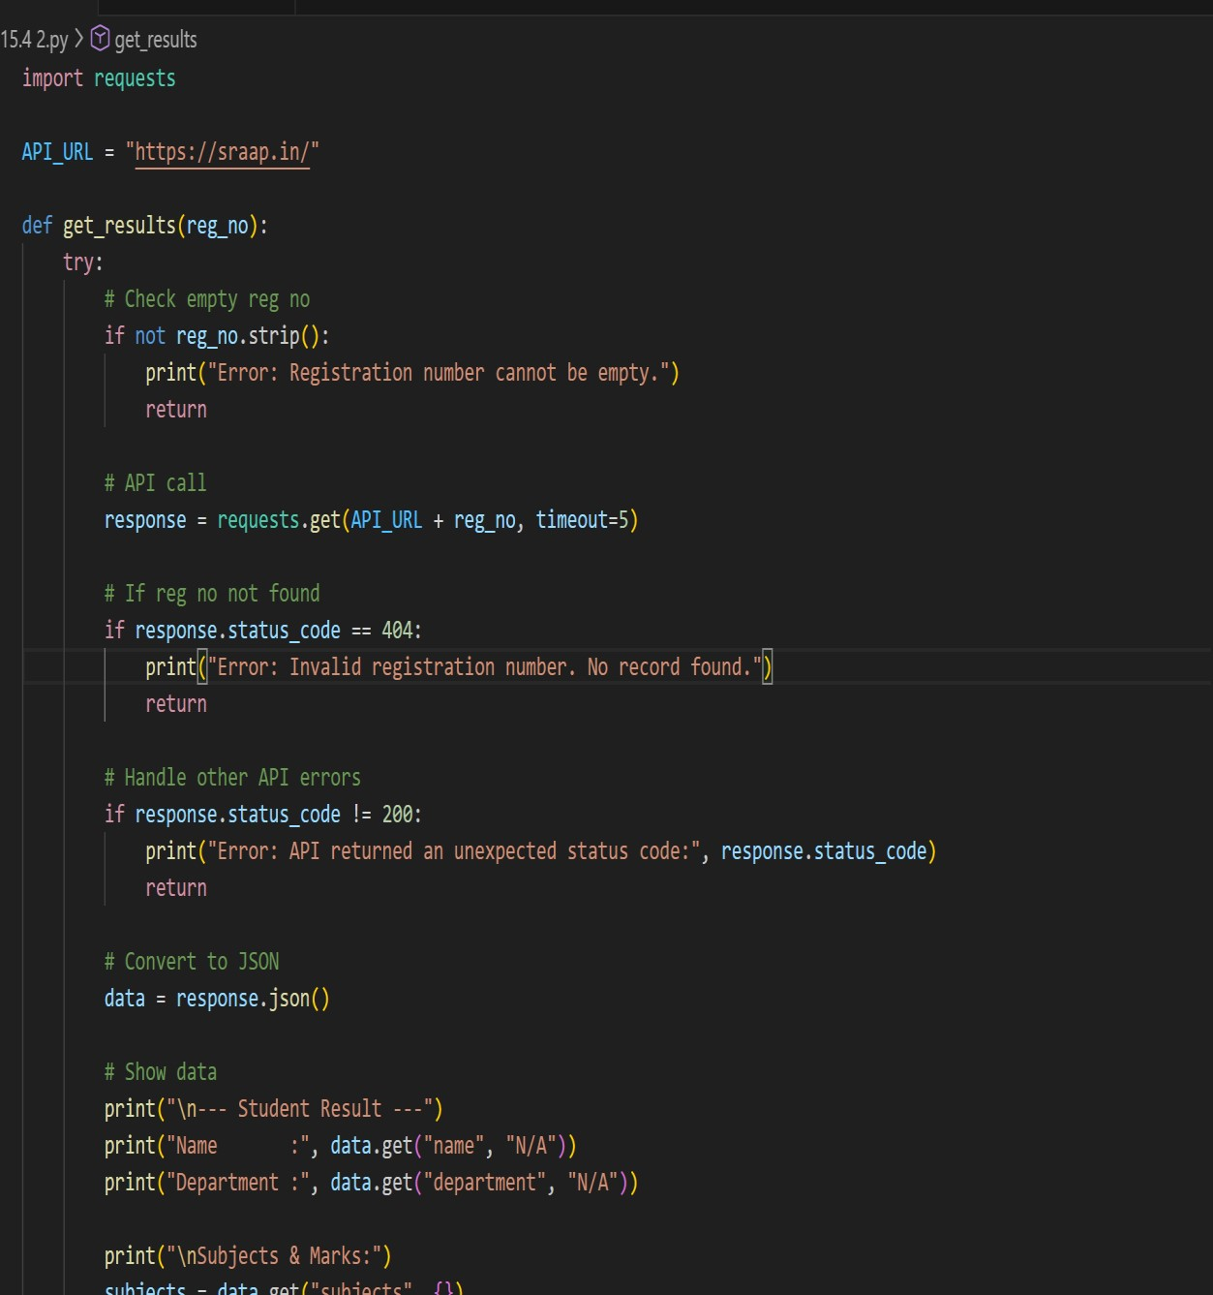

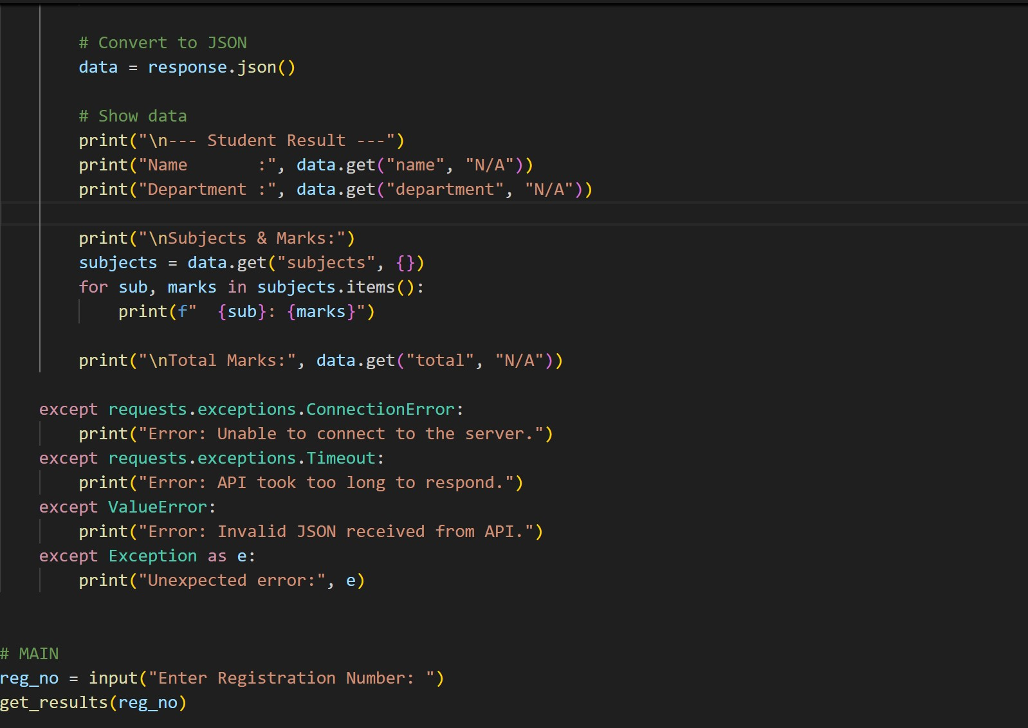

OUTPUT:
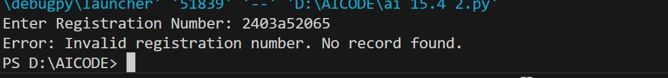
OBESRVATION:
The program takes a registration number from the user and sends it to a University Results API. It uses error handling to check for empty or invalid registration numbers, API errors, and connection issues. Since the API is a dummy link, the program displays an error message, showing that the error handling works correctly.

TASK:2
Q2. (Code Translation)
- Convert a Java Streams API example into Python list comprehensions.
- Validate correctness of output
PROMPT:
Write a Python program that converts a Java Streams API example into Python using list comprehensions. Show both the Java example and the equivalent Python code. Also verify that the Python output matches the expected Java output."Write a Python program that converts a Java Streams API example into Python using list comprehensions. Show both the Java example and the equivalent Python code. Also verify that the Python output matches the expected Java output."
CODE:
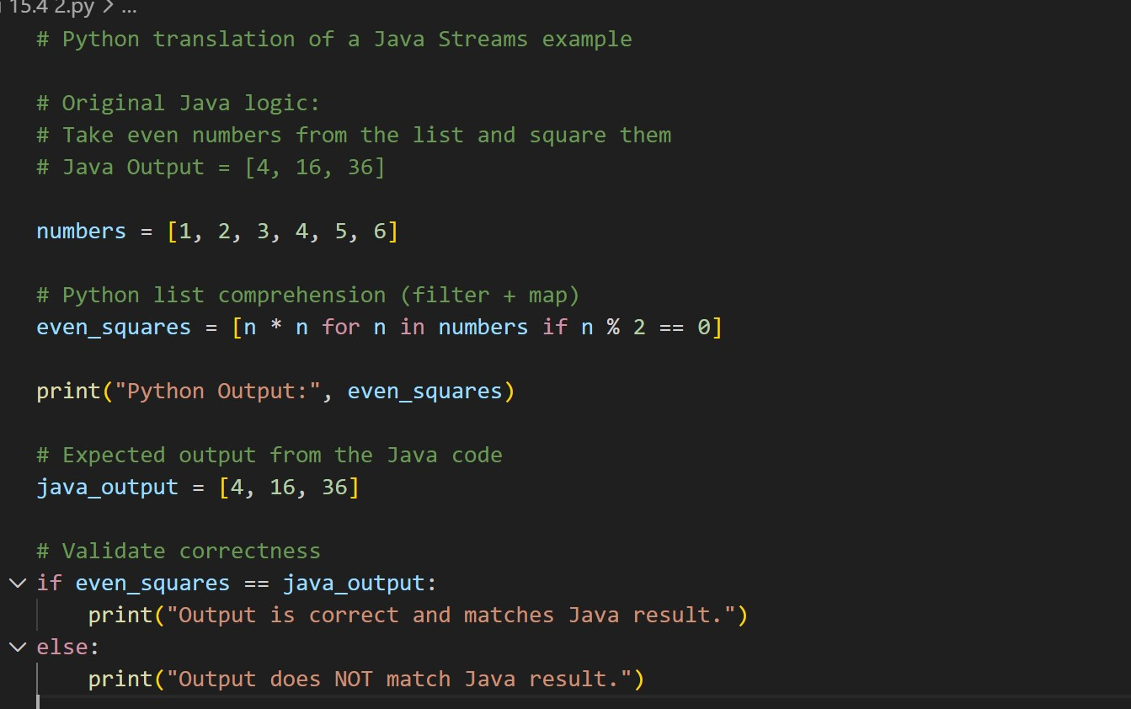
OUTPUT:
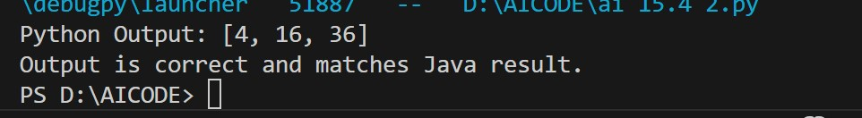
OBSERVATION:
The Java Stream operations (filter + map) were successfully translated into a single Python list comprehension. The output from Python matched the expected result from the Java Streams code, confirming the correctness of the translation.

